02.09.2014
Red Bull and branded content 360°
In one of the latest RedBull posts on LinkedIn it can be read they have an average of organizing 4,7 events a day, globally. We shouldn't forget it's not only fun giving wings to its participants but it's a carefully planned strategy of content marketing which allows direct participation and sharing the emotions. This is Filmteractive selection:

The Red Bulletin
Press articles are not enough these days. RedBull went a step further publishing their own magazine. 100 pages Red Bulletin, added to popular journals, is published in 12 countries, on 5 continents. The magazine does not include articles about the energy drink but its devoted to physical activity, culture, tourism and health. It also includes interviews with music, cinema and extreme sports stars. The magazine is an element of brand's permanent promotional campaign not focused on the product itself but on a certain lifestyle associated with the product. That's how it manages to reach a certain target group of consumers.

Red Bull Stratos
RedBull mastered the effective usage of a wide range of media what is reflected the realisation of RedBull Stratos project. Felix Baumgartner mission of 39 kilometres skydiving after a jump from helium balloon has become a famous media event and arouse interest of TV viewers and internauts. This spectacular achievement of this man from Austria was watched live by 8 million viewers and its YouTube version has been watched four times more up till now. The characteristic logo with a red bull on his capsule has appeared in all press materials and even broadcasts giving the beverage a promotional campaign of global reach. The famous jump was not only a stunt man's show but a an outcome of eight years of scientific works aiming at gathering new data and knowledge for the improvement of suborbital flights.

Extreme Marketing
The energy drink is associated with physical effort, activity and the dynamic pace of life of the young. Is there a better way to illustrate it than by a series of films with successful sportsmen of many disciplines? Starting from skateboarding and BMX, through snowboarding and surfing and ending at motor and extreme sports - RedBull accompanies daredevils who want to push the boundaries of human possibilities, break the laws of physics and give viewers some shivers. RedBull Media House productions promote sport achievements from all over the world as well as the way of life and thinking of people who make them. Thanks to such approach it is able to sketch their profiles, show personalities and bring closer their attitude to life and the risk they take. The beverage's producer organizes and sponsors X-Fighters, Air Race, Storm Chase and Big Wave Africa competitions, sport teams and individual sport's men, also from Poland. That's how RedBull proves its unbreakable connection to adrenaline, strong emotions and extreme performances of positive influence on the brand.

„World of Red Bull”
Today's marketing campaigns cannot exist without more and more popular social media. RedBull actively uses social media services like Facebook, Pinterest, YouTube, Twitter or Instagram. It shares photos, film and animations characteristic for the brand, targeted at young people. It also encourages them to participate in the community gathered around brand's values. Fans exchange links, self-made films and stories of extreme events from their lives. They can find interesting materials, play online games and meet sportsmen and artists supported by the beverage producer. All those actions let them forget about the product itself and focus on the content created by RedBull in its own production studios and during the sponsored events. This way they can enter the World of RedBull.
Bernhard Hafenscher, Head of Commercial Distribution will be a special guest on this year's Filmteractive. He will appear on the 24th of September in Lodz Film School to tell how Red Bull Media House has developed its 360° approach into a global production of branded content. The full programme of the conference is available at:
http://filmteractive.eu/conference-programme.php

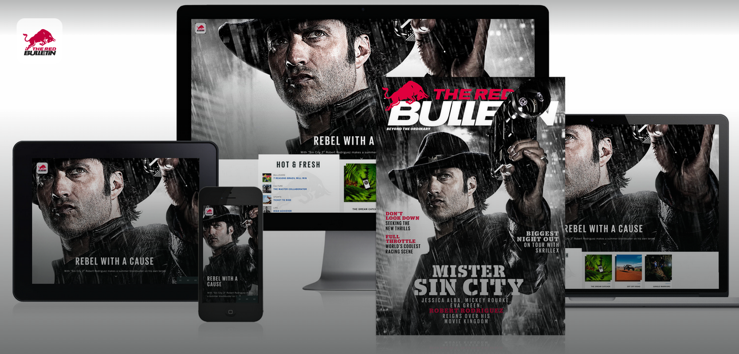
http://www.redbulletin.com/
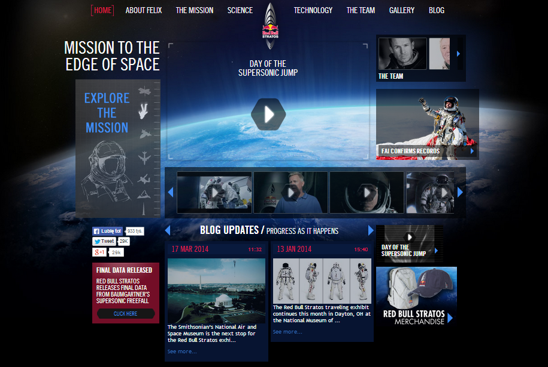
http://www.redbullstratos.com/

